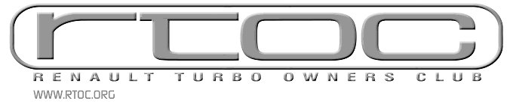

In conjunction with The Renault 5 owners club

*Title (Mr, Mrs, Dr, etc)
*First Name
*Surname
*House No./Street
*Town
*County

*Postcode
*Country
Home Tel. inc. STD
Mobile Tel.
Work Tel. inc STD
E-Mail Address
*RTOC website username if you’ve registered there

* Required

Make
Model
Colour
Year

Where did you hear about the club?

Return this form with a cheque for £25 payable to Renault Turbo Owners Club to:

RTOC Membership Secretary
57 Broadheath Avenue
Bidston
Wirral
CH43 7NP

